Ethan Massingill

The first change I added was I saw the need that I had 0 dedicated firewalls on the network along with not having a DMZ area for my servers specifically. So I added 2 firewalls and moved router 0 to be a dedicated outside router, with ASA1 being the forward facing firewall to reach the internet. ASA2 was placed between the server room switch and the west router so that it created a DMZ for the sensitive area. I configured both firewalls using the Inside/Outside Vlan along with re-addressing my inside routers and outside router accordingly. I gave the outside router and address of 10.10.10.3/24 Natting takes place on the forward-facing firewall.

Screen shot of new firewall and router placement

I moved on to creating a Radius Server for my RFID readers located throughout the building, and then assigning the corresponding RFID IP addresses to the server.

Radius server setup

Next I focused on adding SCADA devices to the network. I made one of my servers an IOT controller, along with adding a power meter to monitor the Wind Turbine. Likewise for physical security I added a motion sensing light outside and several camera’s, all of which are controlled remotely by the IOT controller. The camera’s themselves are not connected by wifi, but instead rely on PoE physical connection.

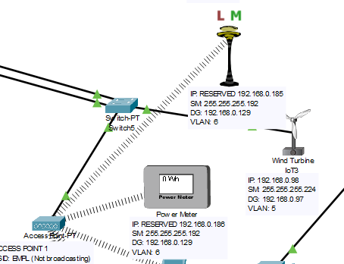

I then focused on securing the Access points correctly with including the SSID, WPA2-PSK, and made sure the devices were able to connect to it.

Adding IoT5 (Power Meter) to the Access point with the information

Finally, I moved to the switches and started including, where needed, specific port security for the mac addresses. Here I made sure it learned the mac address through the sticky method with cisco, and then told it to shut down the port if another mac address, other than the one learned, tried to connect. The only one that did not have this was my public wifi since it would have unseen mac-addresses connecting to it. I then force shut down all unused ports on the switches and servers.

Adding port security for the mac-address of each currently connected device. Here specifically is the RADIUS server being assigned to port fa0/2.

Zoomed out updated network

West side of new network design (easier to see the AP’s information)

East side of new network design